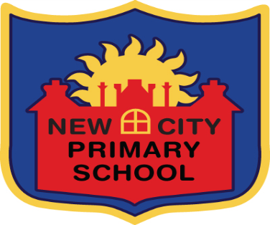

New City Primary School Curriculum
Purpose (Intent)
The purpose of our curriculum at New City Primary School is to ensure that all our children are prepared learners for the 21st Century and are responsible global citizens. Our curriculum will introduce our children to the essential knowledge, skills and understanding that will help them develop a love for their lifelong learning. We want our children to be confident, resilient and independent learners and ensure that they have an appreciation of their own place in the wider world.
At New City we want our children to be proud and passionate about their learning and have a desire to be successful within and beyond the school day. Our curriculum is designed to provide an outline of core knowledge around which our teachers can develop exciting and stimulating lessons to promote the development of children’s knowledge, understanding and skills as part of the wider school curriculum.
Aims (Implementation)
- To deliver a curriculum that ensures that children develop their skills and knowledge progressively and enables children to communicate their understanding and what they remember both orally and in writing.

- To design sequences of learning in each subject that inspires, challenges and engages children through the use of a range of teaching strategies including: practical activities, hooks, resources, visits, outdoor learning, speakers, and workshops. To ensure the topics taught within the subject enable children to develop depth and breadth of understanding.

- To promote the New City curriculum within the local, national and international context and make explicit links to the world beyond the school gates.

- To ensure that the children are exposed to high level subject vocabulary and can articulate their understanding confidently using the correct terminology.

- To ensure the curriculum is accessible to all children through carefully planned and delivered lessons that is inclusive and ensures all children are able to succeed.

- To promote links across the curriculum to enable learning to be contextualised, exciting, creative and fun.

Outcomes (Impact)
Children are engaged and motivated about their learning at New City Primary School. They demonstrate a love and passion and are able to talk and write about their learning and how it links to the modern world confidently.
The enriched curriculum will have prepared the children for their transition to the next phase of their learning by equipping them with the skills of resilience, curiosity, independence and proactivity to ensure they continue to be successful.

