New City Primary School (W/C 25th May 2020) This weeks book:
Nursery | Monday | Tuesday | Wednesday | Thursday | Friday
08:50 – 9:15 | Joe Wicks - PE | Joe Wicks - PE | Joe Wicks - PE | Joe Wicks - PE | Joe Wicks - PE
9:15 –9.30 | Phonics:  c , k  https://www.youtube.com/watch?v=bZNxhoxSAFA  https://www.youtube.com/watch?v=ZSuDDRG2P-c  https://www.youtube.com/watch?v=1dhzPuT6jm0  https://www.youtube.com/watch?v=OGVbUgqp7LQ | Phonics:  c , k  https://www.youtube.com/watch?v=bZNxhoxSAFA  https://www.youtube.com/watch?v=ZSuDDRG2P-c  https://www.youtube.com/watch?v=1dhzPuT6jm0  https://www.youtube.com/watch?v=OGVbUgqp7LQ | Phonics:  c , k  https://www.youtube.com/watch?v=bZNxhoxSAFA  https://www.youtube.com/watch?v=ZSuDDRG2P-c  https://www.youtube.com/watch?v=1dhzPuT6jm0  https://www.youtube.com/watch?v=OGVbUgqp7LQ | Phonics:  c , k  https://www.youtube.com/watch?v=bZNxhoxSAFA  https://www.youtube.com/watch?v=ZSuDDRG2P-c  https://www.youtube.com/watch?v=1dhzPuT6jm0  https://www.youtube.com/watch?v=OGVbUgqp7LQ | Phonics:  c , k  https://www.youtube.com/watch?v=bZNxhoxSAFA  https://www.youtube.com/watch?v=ZSuDDRG2P-c  https://www.youtube.com/watch?v=1dhzPuT6jm0  https://www.youtube.com/watch?v=OGVbUgqp7LQ
9.30-10.30 | Book of the week:  https://www.youtube.com/watch?v=s_fIEWViJyE English- letter formation  What did you do over the weekend?  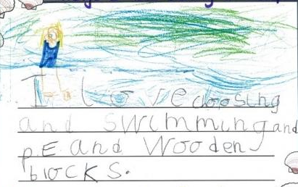  Draw a picture of what you did over the weekend.  Support children in sounding out the word and writing down the initial sound. | Book of the week:  https://www.youtube.com/watch?v=s_fIEWViJyE English- letter formation  Can you write the sounds of the week?  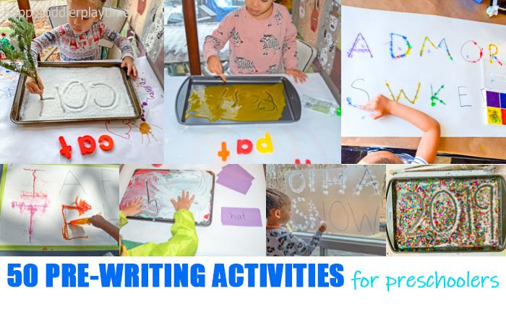  Ask the children to form the ‘c’ and ‘k’ sound.  You can use shaving foam/flour/sugar for the messy play | Book of the week:  https://www.youtube.com/watch?v=s_fIEWViJyE English- Letter formation  m n d c a t  Say the sound of each letter above and encourage your child to write them down.  Now try saying the whole word below and ask your child to write down all the sounds they can hear. Encourage them to sound out independently.  m a n  c a t  t a n  c a n  t a c | Book of the week:  https://www.youtube.com/watch?v=s_fIEWViJyE  English- letter formation  Can you draw a flower?  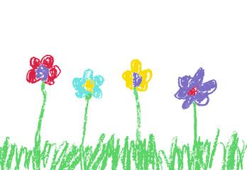  Draw a picture of a flour and use adjectives to describe the flower.  e.g. Tall flower  What colour is your flower?  How many flowers did you draw?  Encourage children to write down their replies using their sounds and numbers. | Book of the week:  https://www.youtube.com/watch?v=s_fIEWViJyE English- book review  Read your favourite story to your family.  After reading the story explain to the children that their teacher wants to know about the story. Can they draw a picture of their favourite part of the story? Encourage children to use their sounds to describe their favourite part.
10:45 – 11:45 | Maths - Number formation  https://www.youtube.com/watch?v=0VLxWIHRD4E | Maths -ordering  I can order numbers 1-10 | Maths – Halving  https://www.youtube.com/watch?v=eBWTP84lcUI  You will need :  3 bowls (2 of the same colour)  Counting objects | Maths – Halving  1. Draw some circles on a blank piece of paper.  2. Ask children to count the amount and write down the number.  3.Then ask them to colour in half  4. Count how many you have coloured in and repeat the activity. | Maths – Halving  https://www.youtube.com/watch?v=eBWTP84lcUI
11:45 – 12:30 | Practice writing your numbers from 1 – 10. 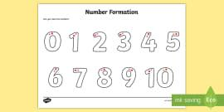  You can print off free resourse from twinkl | 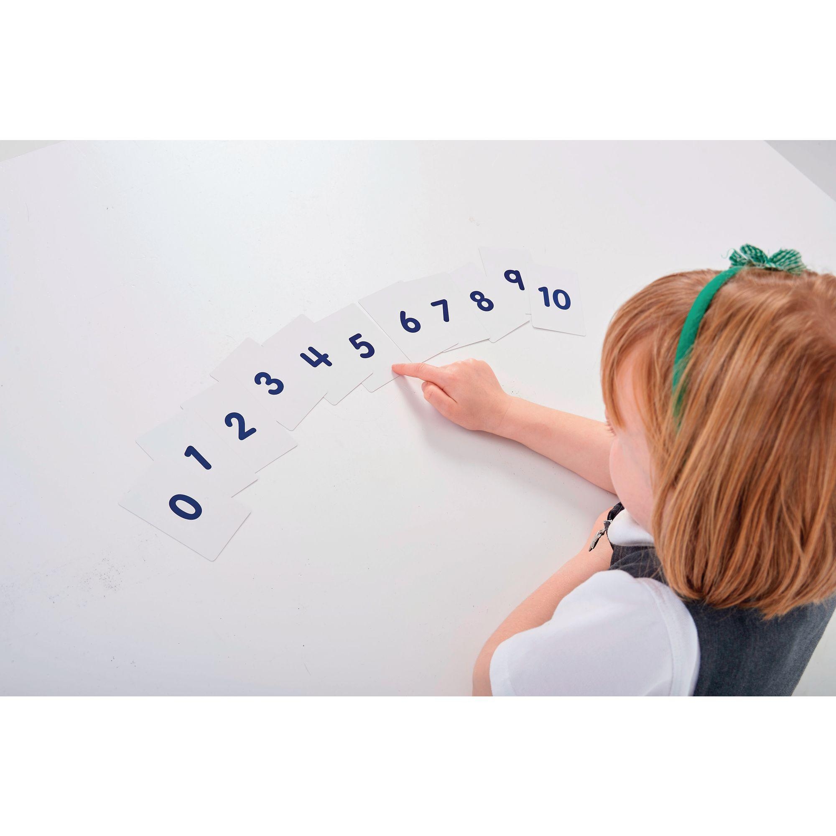  Let your child order the numbers then name the number. They can then order then from 10 to 1 and name them. | 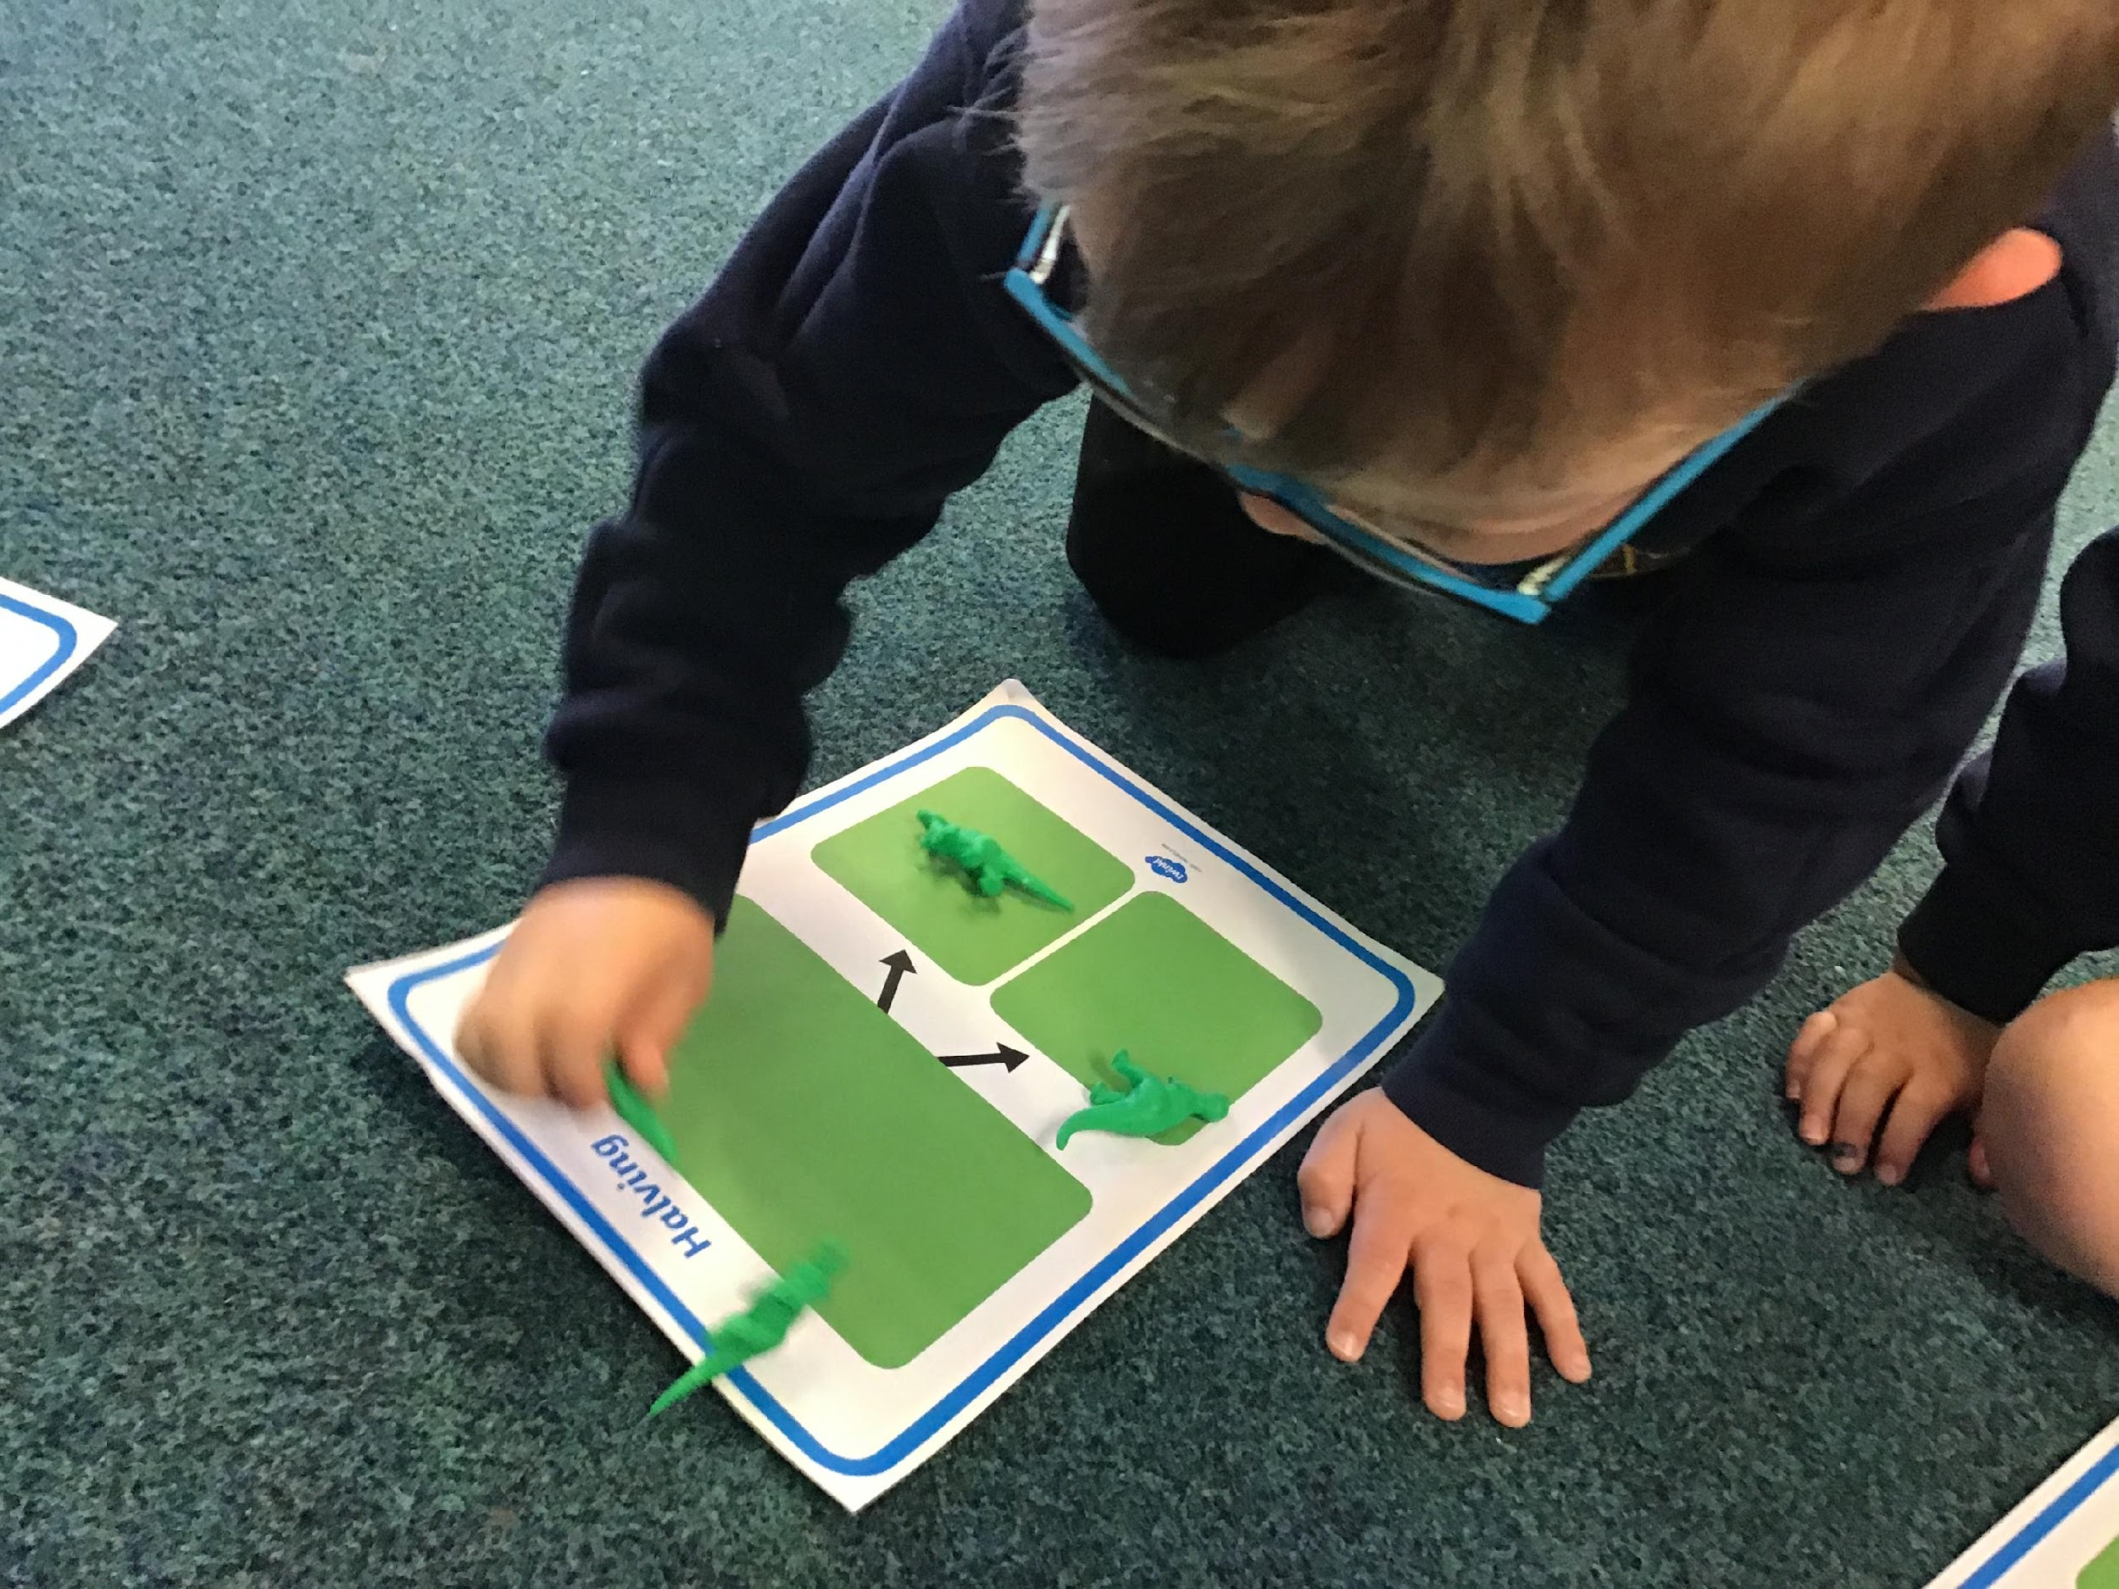  Place an even amount of objects into one bowl then ask your child to share the counting obejcts between the two same coloured bowls.  Emphasise that they need to put one in each bowl and not two in the same bowl. | 4  4  4  2 | Place an even amount of objects into one bowl then ask your child to share the counting obejcts between the two same coloured bowls.  Emphasise that they need to put one in each bowl and not two in the same bowl.
1:30 – 2:45 | Health and social care/ Maths  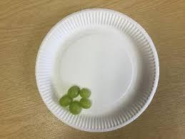  Can you find half?  Using food (anything that can be cut) ask children to count how many they have at the start. Then ask the children to cut the items in half and count how many they have now. | Health and Social Care:  Can you prepare a healthy meal for your family?  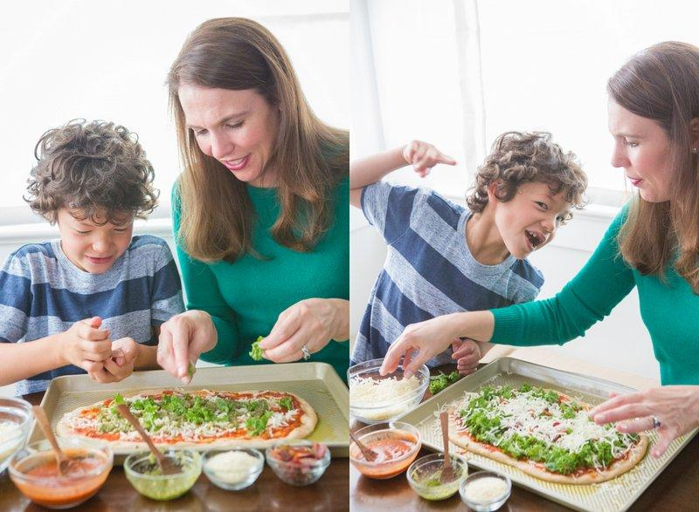  Send in pictures of what you’ve made via Evidence Me app  Or Email  Nursery@newcity.boleyntrust.org | Expressive arts and design  Keywords  Dynamics = Volume of sound.  Forte and Piano are used to describe dynamics in music.  forte = loud  piano = quiet  What forte and piano sounds can you make with your body? Can you change between the two? | ICT  Can you find the initial sound?  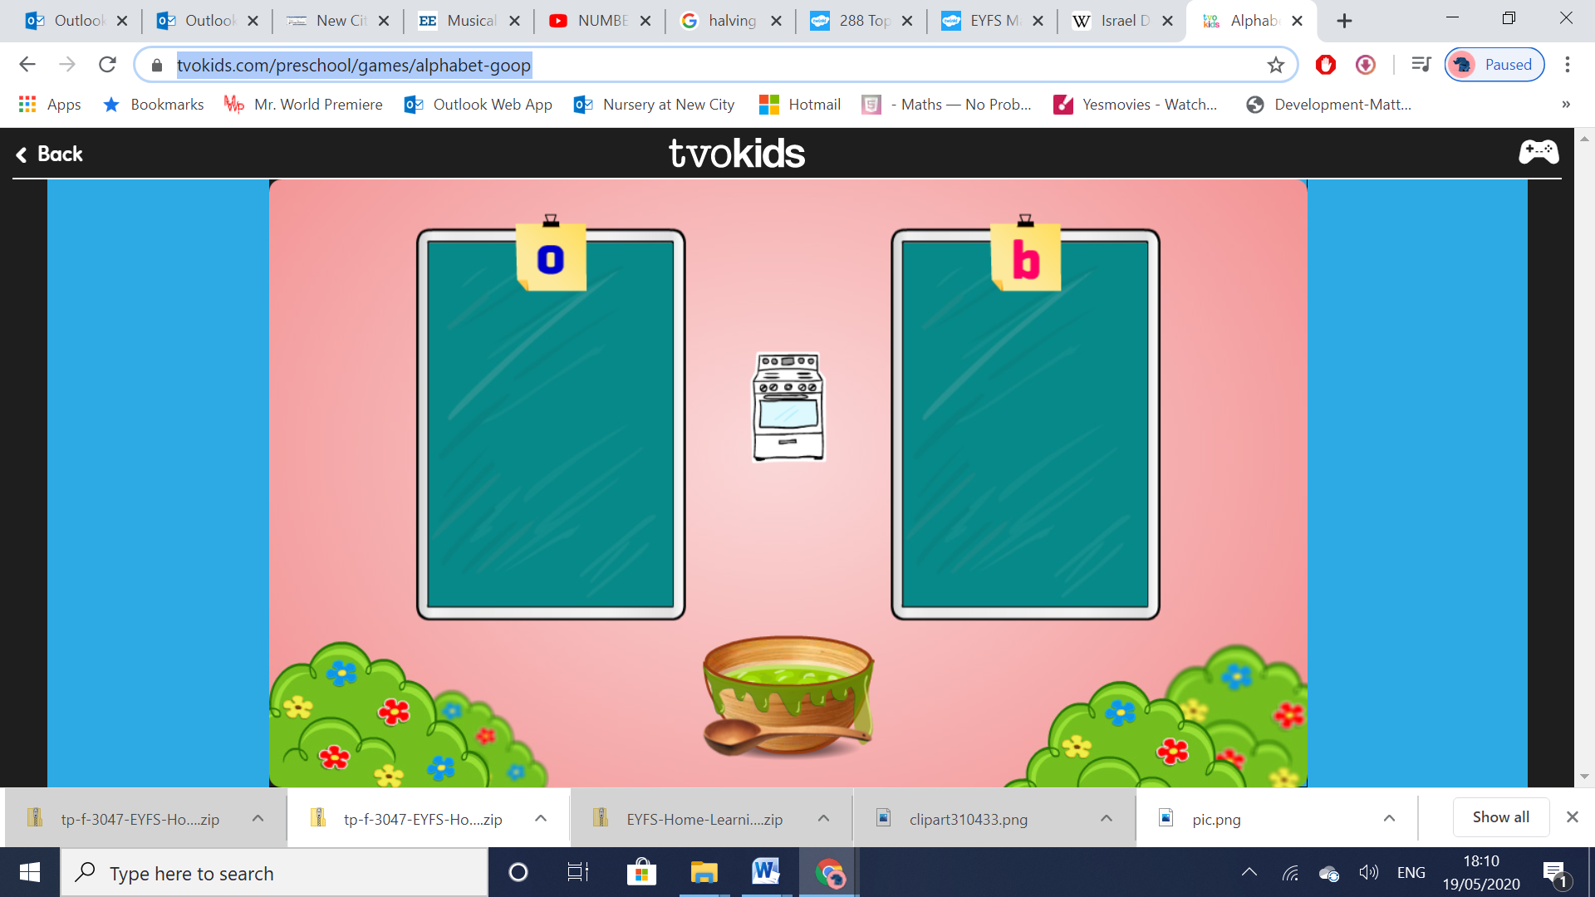  Children to place the object into the correct column by listening to the initial sound.  e.g Oven … O sound or the b sound. | Expressive arts and design  Can you make a bubble shaker?  You will need:  -An empty 500ml bottle.  -1 sock  -Scissors  -Elastic band/hairband  -Washing up liquid and bowl.  1. Cut off the bottom of a plastic water bottle with scissors and remove the lid at the top of the bottle.  2. Pull a sock over the bottom opening of the bottle.  3. Cut off the excess sock over 2” from the bottle bottom.  4. Secure with rubber bands.  Mix washing up liquid or bubble mixture with water and place in a bowl.  5. Dip sock end into bubble mixture dish and blow through the mouthpiece
3:00 – 3:10 | Bug Club  https://www.activelearnprimary.co.uk/login?c=0

