New City Primary School (W/C 25th May 2020)
Send any photos of what your child has made or done to learninghub@newcity.boleyntrust.org

Learning Hub | Monday | Tuesday | Wednesday | Thursday | Friday
08:50 – 9:15 | We’re going on a bear hunt song  https://www.youtube.com/watch?v=5_ShP3fiEhU | Freeze song https://www.youtube.com/watch?v=2UcZWXvgMZE | Dinosaur stomp https://www.youtube.com/watch?v=gzesbQaqhCY | Hello song https://www.youtube.com/watch?v=x23rTDl4AMs | We’re going on a bear hunt song  https://www.youtube.com/watch?v=5_ShP3fiEhU
9:15 –9.30  Phonics | Phonics:  https://www.youtube.com/watch?v=T4IfiKiQ-3I  Practice the jolly phonics sounds. Use your mark making tools to write the ‘sounds or do them in the air with your finger? Can you make your own flash cards? | Phonics  Ask the children to practise forming the letters in the messy play.  You can use shaving foam/flour/sugar for the messy play | 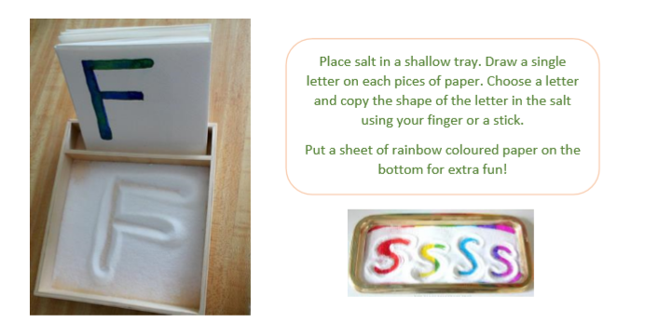  Phonics:  Place salt in a shallow tray. Draw a single letter on each piece of paper. Choose a letter and copy the shape of the letter in the salt using your finger or a stick.  Put a sheet of rainbow coloured paper on the bottom for extra fun! | Phonics:  https://www.youtube.com/watch?v=rlLz3Vh2-6k  Practice the jolly phonics group 2 sounds. Use your mark making tools to write the ‘sounds or do them in the air with your finger? Can you make your own flash cards? | English-Writing  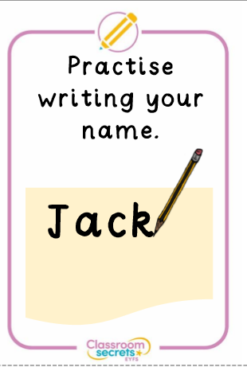  Can your child have a go at writing their name? Or can you write their name? They could trace over it with their finger or try and copy the pre-writing shapes.
9.30-10.30  English | We’re going on a bear hunt  https://www.youtube.com/watch?v=0gyI6ykDwds  Draw a picture and write about what happened in the story.  Encourage children to draw their favourite part of the story and write a sentence about the picture. Support them in writing the sounds they can hear. E.g. ‘br’ for bear  Support children in sounding out the word and writing down the initial sound. 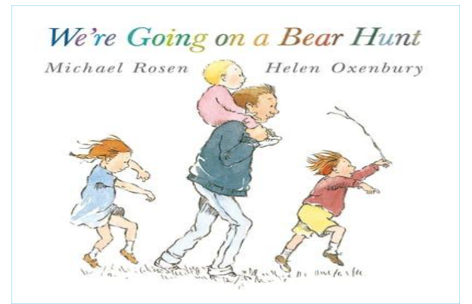 | Water painting  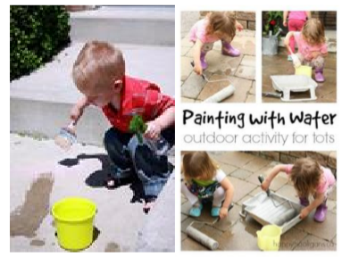  If you have access to a garden or outside area with concrete floor or brick walls, this is a great way for children to enjoy ‘mark making’. Using just paintbrushes and rollers fill buckets and roller trays with water and let them paint the water over the dry surfaces to see it change colour. | English-Writing  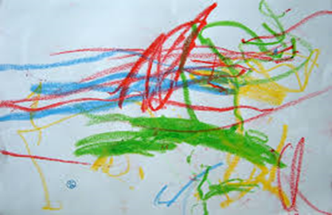  Use the sheet in the home learning resources. What can they write?  Can they tell you what they have written? What hand do they use? How do they use the pencil? | We’re going on a bear hunt story telling  Can you retell the story . Ask your child to draw a picture of the story. Can they do the actions?  Can you make your own small world of the story?  e.g. use cocoa for mud  blue material for water  sugar for snow 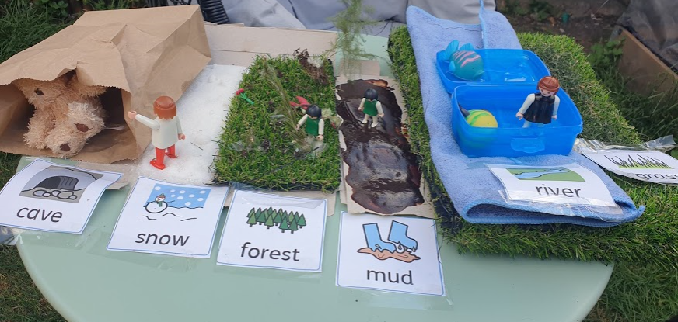 | Pre writing skills  Use the prewriting skills sheets and get your child to use any mark making tool to trace over the shapes.
10:45 – 11:45  Maths | Five little speckled frogs https://www.bbc.co.uk/cbeebies/watch/numberblocks-five-speckled-frogs-song  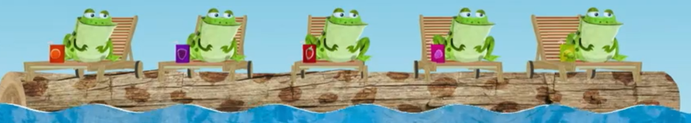  Sing along to five little speckled frogs.  Can your child join in and use their fingers to show the correct number. | Numbers  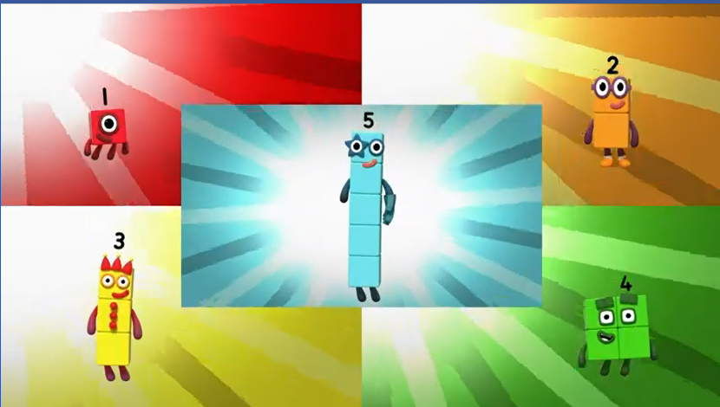  Practise number formation 1 – 5.  Use paper and pencils or messy play or playdough.  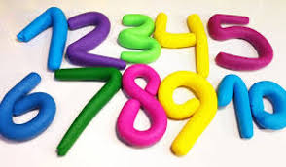 | Numbers  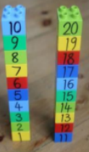  Write numbers on the duplo bricks. Name the number your child picks up. Model building a tower. | Maths – Feed the bear  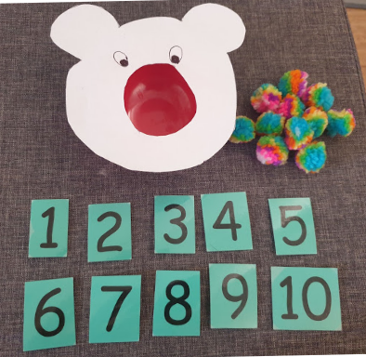  Use a bowl and place objects one by one in it. You could cut out a bear shape and a hole for it’s mouth and put objects in the bear’s mouth.  Say a number or point to a number can they put the correct number of objects in? Use play food or pasta. | Number puzzles  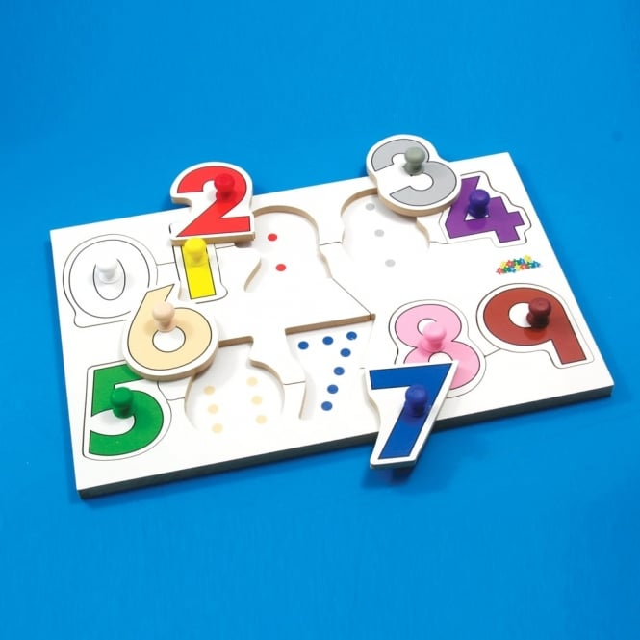  Use any puzzles you have at home and let your child have a go. Can they match the shape without help? Are they able to turn the piece to fit in the puzzle?
11:45 – 12:30  Movement  and music | Blowing bubbles  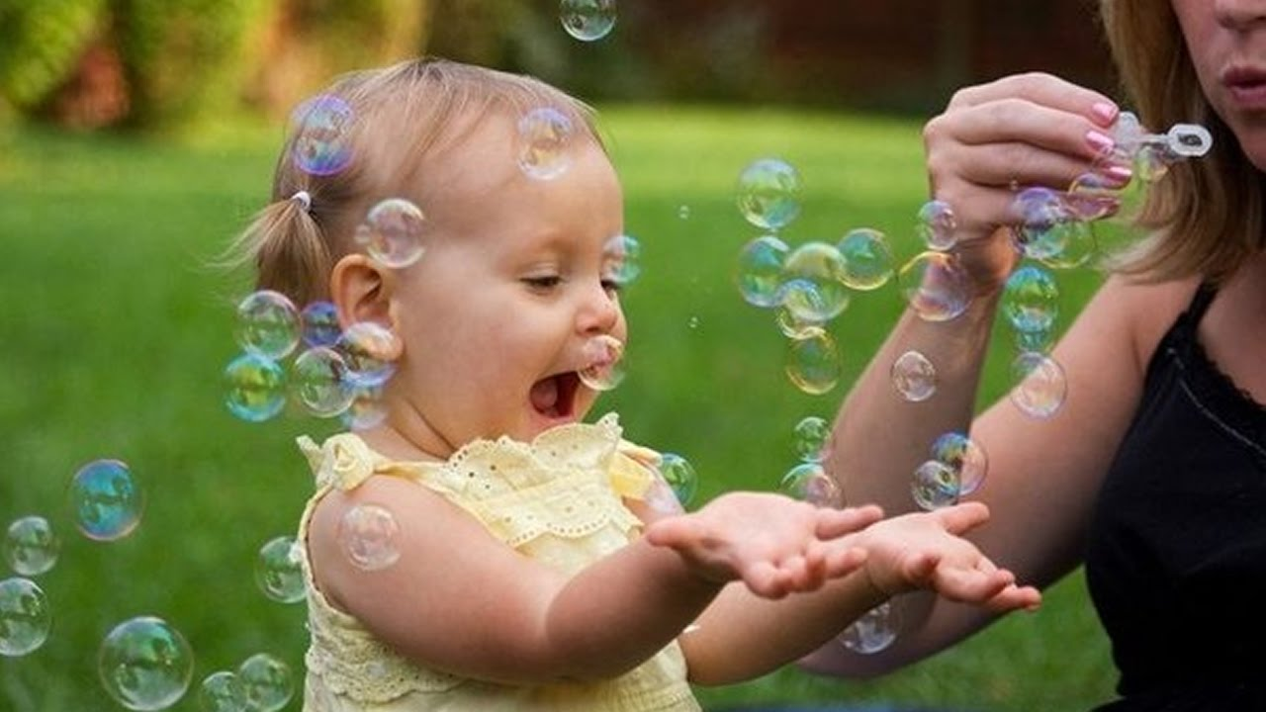  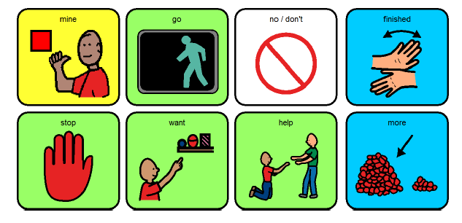  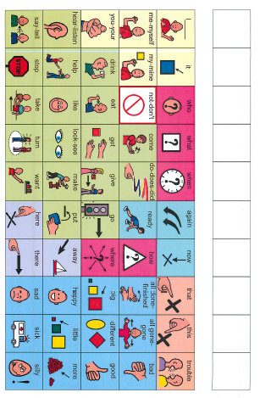Blow bubbles for your child. Can they pop them? Say Ready, Steady, go.  Model using the core board pointing to ’more’ or ’go’ and encourage child to have a go at using core board if they’re able to. | Art/ fine motor  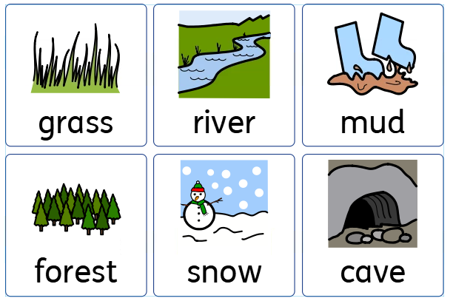  Can you create your own bear hunt small world? You can draw it, use material to make it or paint it.  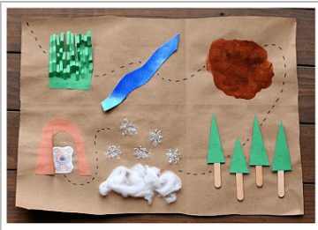 | Simon says  https://www.youtube.com/watch?v=lob3Q7TKmQQ  Play a game of Simon says .  Simon says – jump  Simon says – clap  Simon says – hop  Can they follow the instructions? Model what each action is. | PE:  Throwing and catching  Have a game of catch with your child or can they throw and catch the ball themselves.  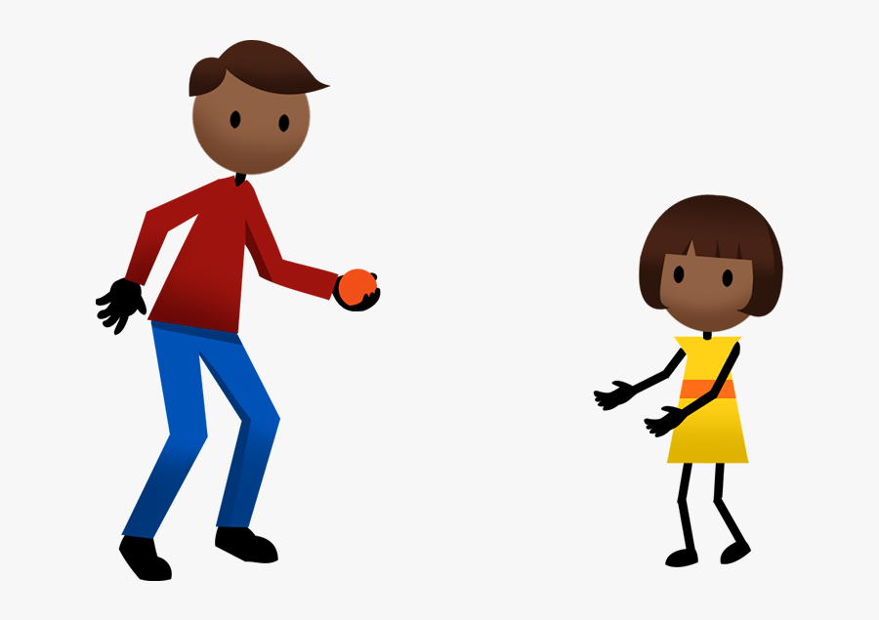  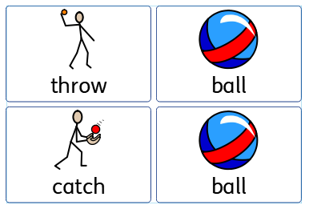 | Fine motor skills  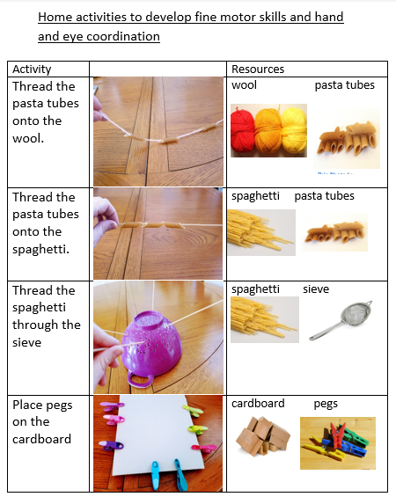  Use the sheet in the home learning resources. What can you use to practise the fine motor skills? Spaghetti threading/ pasta threading?
1:30 – 2:45  Other subjects | Music  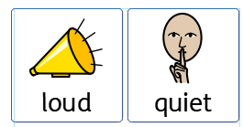  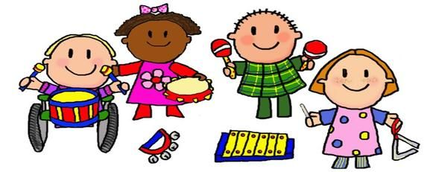  Can your child make noises that are loud?  Can they make noises that are quiet?  Can you make an instrument using plastic pots, wooden spoons or whatever you have in the house. | Water Play  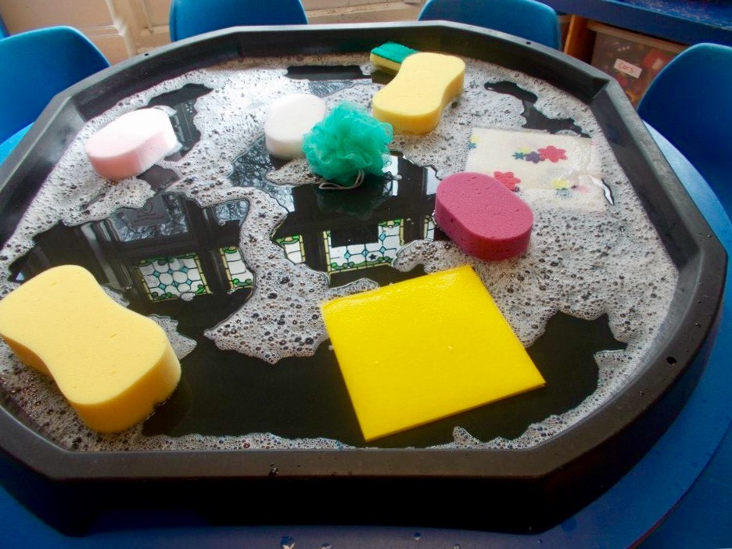  Can you set up a water play area use a tray, or bucket, bowl to explore water.  Use any toys, cups, funnels whatever you have at home for your child to explore the water. | Art  Draw a bear outline. Then your child can decorate the bear.  What colours do they use? What materials do they choose to decorate the bear? | Construction  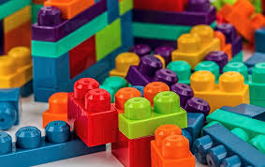  Let children build whatever they would like. Follow your child’s lead. What do they like to build? Can they say the colours or count the blocks? | Intensive Interaction 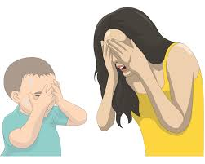  Peek-a-Boo: Covering your eyes with a scarf or your hands, enjoy this simple interaction. Encourage excitement, anticipation, and surprise in the tone of your voice
3:00 – 3:10 | Reading for pleasure (books at home or using BugClub) https://www.activelearnprimary.co.uk/login?c=0
Send any photos of what your child has made or done to
learninghub@newcity.boleyntrust.org

