Cocomelon nursery rhymes | 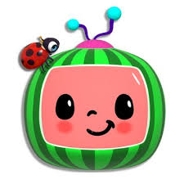 | www.youtube.com  Search for cocomelon nursery rhymes  selection of well known nursery rhymes and number songs
Bug club | 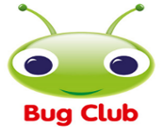 | https://www.activelearnprimary.co.uk/login?c=0  log into your child’s account to access their books
Science sparks | 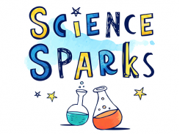 | https://www.science-sparks.com/  selection of science activities for children if you look at pre school science
Cbeebies radio | 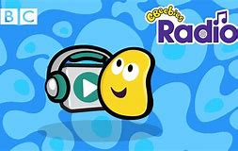 | https://www.bbc.co.uk/cbeebies/radio  stories and songs for your child to listen to
Cbeebies story | 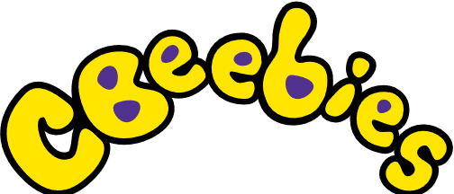 | https://www.bbc.co.uk/cbeebies/stories  stories for your child to watch and listen to
Sensory app house |  | https://www.sensoryapphouse.com/  Range of apps for ipad for children.  Recommend painting app, plazma calming lava bubbles, splodge tap and paint,
Big Top musical adventure |  | www.youtube.com  Search for “Big top musical adventure”  Accessible online resources for our families and friends to have their own musical adventures at home.
Recommended websites

