Mark making activity

[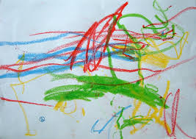](https://www.google.co.uk/url?sa=i&url=https%3A%2F%2Fwww.earlyyearscareers.com%2Feyc%2Flatest-news%2Fthe-importance-of-mark-making-in-the-early-years%2F&psig=AOvVaw1LOQx6iKsOMYtclGBnZ3UW&ust=1587546713915000&source=images&cd=vfe&ved=0CAIQjRxqFwoTCJiolceW-egCFQAAAAAdAAAAABAD)[](https://www.google.co.uk/url?sa=i&url=https%3A%2F%2Fwww.tate.org.uk%2Fkids%2Fgames-quizzes%2Ftate-paint&psig=AOvVaw22hjgjWDNicm2N6Y0Oc56W&ust=1587547125665000&source=images&cd=vfe&ved=0CAIQjRxqFwoTCIiWl5CY-egCFQAAAAAdAAAAABAD)

Resources you could use

[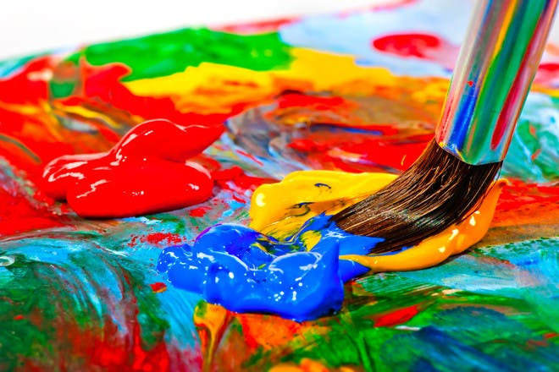](https://www.google.co.uk/url?sa=i&url=https%3A%2F%2Fwww.netmums.com%2Factivities%2Ftop-painting-ideas-for-kids&psig=AOvVaw1X_8NGPZcOfkQeM-bt8P2M&ust=1587547207243000&source=images&cd=vfe&ved=0CAIQjRxqFwoTCMjT27GY-egCFQAAAAAdAAAAABAD)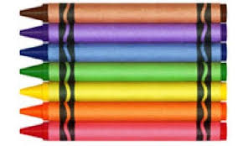 [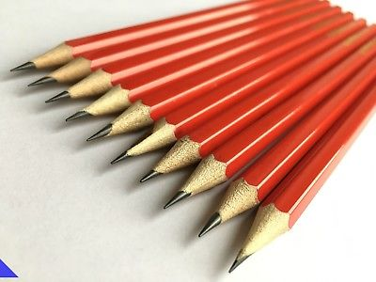](https://www.google.co.uk/url?sa=i&url=https%3A%2F%2Fwww.ebay.co.uk%2Fitm%2FSALE-10-x-PENCILS-HB-DRAWING-WRITING-SKETCHING-ART-SCHOOL-OFFICE-STUDENT-%2F283650099025&psig=AOvVaw2qzRl5iR4IRpX-NJU0fZSP&ust=1587547014528000&source=images&cd=vfe&ved=0CAIQjRxqFwoTCMjAkN2X-egCFQAAAAAdAAAAABAP) 

crayons pencils coloured pencils paint

[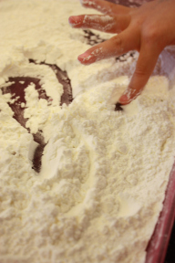](https://playhood.files.wordpress.com/2013/07/img_6755.jpg)[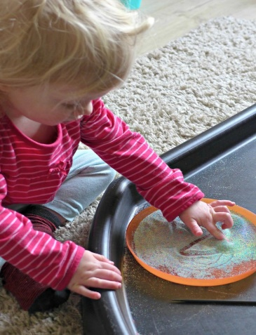](https://i2.wp.com/letthembesmall.com/wp-content/uploads/2016/03/sand-mark-making-1.jpg?ssl=1) [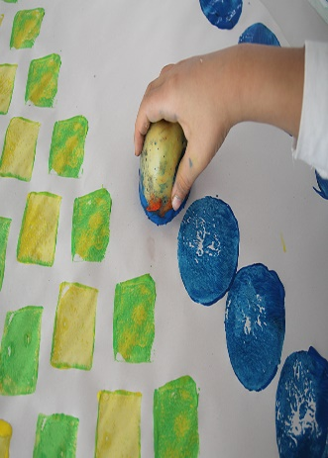](https://www.google.com/url?sa=i&url=https%3A%2F%2Fwww.creativejewishmom.com%2F2013%2F11%2Fpotato-print-and-sponge-stamped-wrapping-paper.html&psig=AOvVaw3r7gVNzAFsYR-XrB2TBSvY&ust=1587547730369000&source=images&cd=vfe&ved=0CAIQjRxqFwoTCOivla6a-egCFQAAAAAdAAAAABAD)[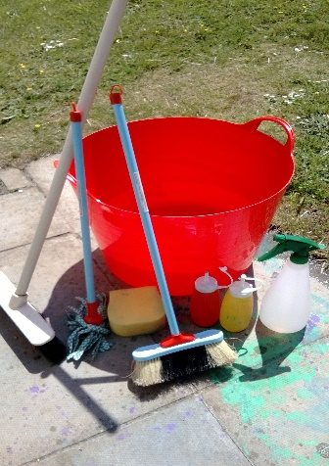](https://www.google.com/url?sa=i&url=https%3A%2F%2Fwww.pinterest.com%2Fpin%2F3659243423369630%2F&psig=AOvVaw3cgsEgKOdm6M0UGs9ieToF&ust=1587547811834000&source=images&cd=vfe&ved=0CAIQjRxqFwoTCIDT6NOa-egCFQAAAAAdAAAAABAE)

flour sand potato water

Here are some ideas to encourage mark making.

What does your child like to use?

Take a photo and send it to me via Studybugs.